**Association Rules**

**Solution – Book**

* Considering the transactions are from a book store, we can understand that the store has 11 types of book.
* I tried different combinations of support, confidence and min length and have made following observations:

1. To see the maximum number of transactions with at least 3 books purchased, following parameters can be set:

* support = 0.1 ; confidence = 0.5 ; minlen = 3
* 28 rules were formed using the above parameters and of those, if sorted by lift ratio, following unique(excluding proliferation) combination can be made:
* ChildBks, ArtBks, GeogBks
* CookBks, DoITYBks, ArtBks
* CookBks, ArtBks, GeogBks
* ChildBks, CookBks, YouthBks
* Observing above combination we can infer that the shop owner can club these (ChildBks, ArtBks, GeogBks,DoITYBks, CookBks,YouthBks) books in a single rack.
* Can refer following scatter plot for better understanding:

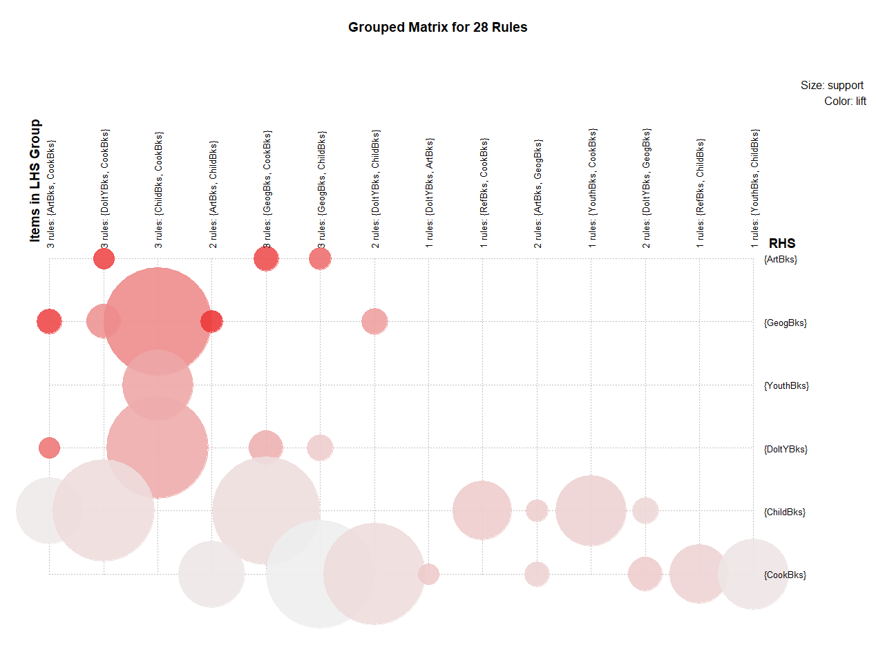

1. Moving forward, we can also calculate the rule for 4 books with following parameters:

* support = 0.08 ; confidence = 0.5 ; minlen = 4
* 20 rules were formed using above paramters.
* Referring below graph the shop owner can plan for bundling offers or arranging the shelves:

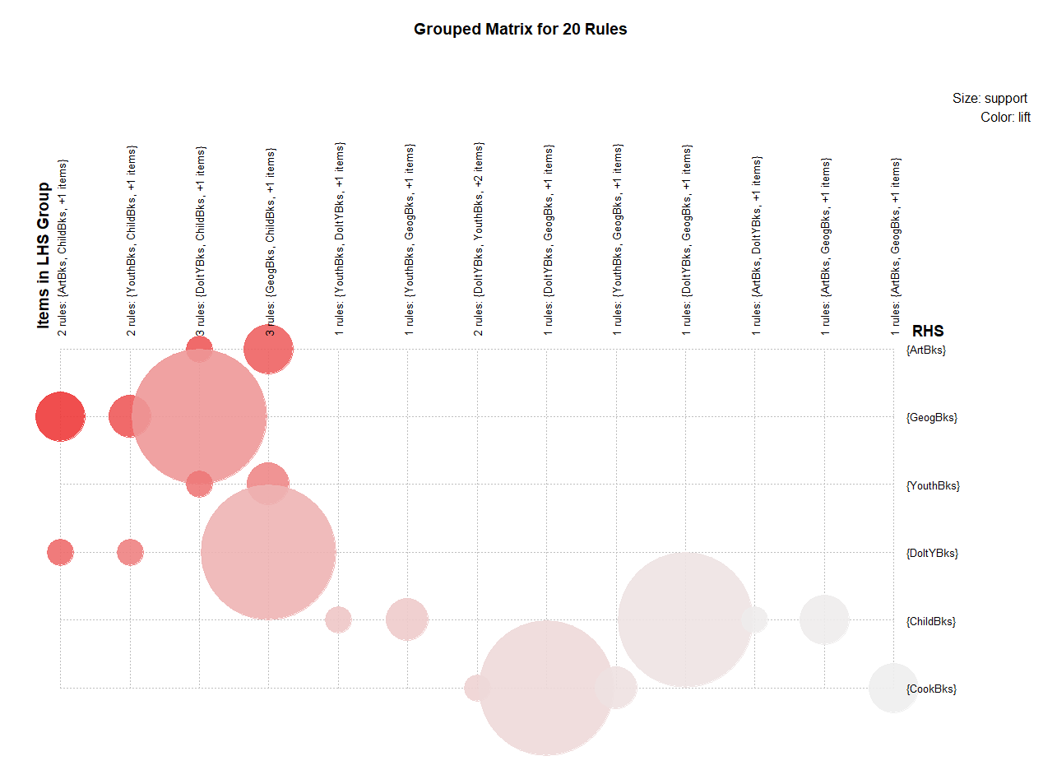

* By changing the parameters we can get different rules as per our requirement.

**Solution – Movies**

* Considering the data is acquired from purchases made by 5 viewers from a movie cassette store.
* I tried different combinations of support, confidence and min length and have made following observations:

1. To see the maximum number of transactions with at least 3 movies purchased, following parameters can be used:

* support = 0.4, confidence = 0.5, minlen = 3
* Excluding proliferation 1 rule was found:
* Sixth Sense, Patriot, Gladiator
* Observing above rule the owner can keep those 3 movie cassette in a single rack.
* Following plot can be referred:

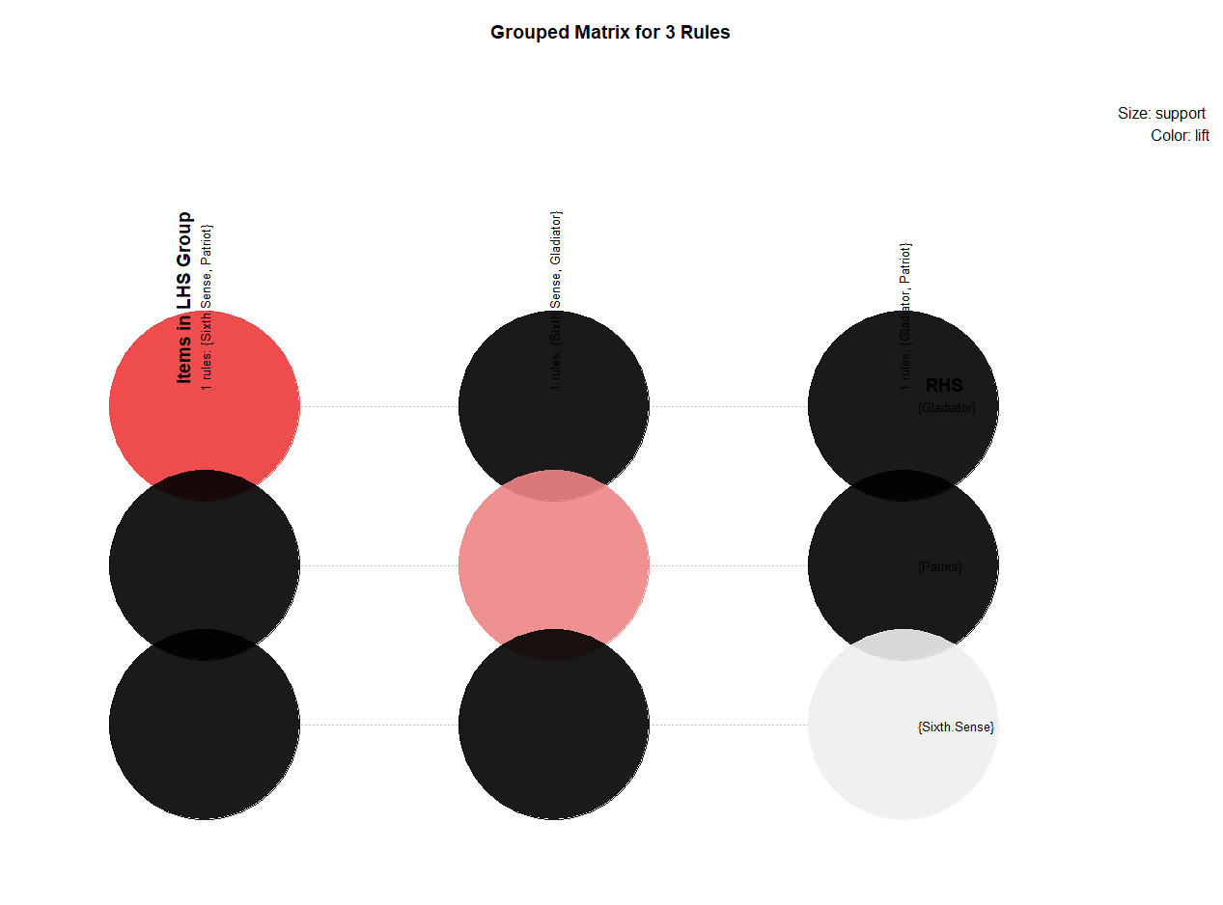

1. Moving forward to see which 2 movie cassettes are sold most, following parameter can be used:

* support = 0.6, confidence = 0.5, minlen = 2
* One unique rule was found using above parameters which had 2movies Patriot and Gladiator.
* May be the shop owner can provide bundling offers on these movies or can plan to keep more movie cassette of movies with same genre.
* Following plot can be referred:

